Our Ocean Backyard
Column No. 321
Gary Griggs
Building on the Beach in Rio del Mar

A series of developments beginning in 1926 brought Rio del Mar into existence. Concrete retaining walls along Aptos Creek and a dam across the creek mouth, filling in the flats and laying out streets and lots changed the area from a natural lagoon and swamp to today’s coastal neighborhood. The description of the area from a 1937 Santa Cruz News article proclaimed that “One hundred new homes are now being planned.. the most pretentious of the new dwellings are being built in the new section of the beach…..under the protective shelter of the towering cliffs”.

The photo below shows Rio del Mar Beach in 1930 with the newly completed Don Rafael Castro Hotel on the bluff top. A road has been built along the base of the bluff and passes on either side of an area that became known as the island. That road became Beach Drive and now extends a mile along the back beach with houses on both sides of the road in places, and out on the sand “under the protective shelter of the towering cliffs”.

A question I often get asked is how can people have homes on the beach? Don’t we own the beach in California? While this seems like an easy question that that should have a simple answer, the fact that there are now dozens of houses built on the sand along Beach Drive suggests that the answer may be more complicated. And Rio del Mar isn’t alone. A short distance upcoast between New Brighton and Seacliff state beaches, homes are built on the sand at Pot Belly Beach and along Las Olas Drive. Houses are built on the beach at Del Mar in northern San Diego County, at Broad Beach in Malibu, and at a lot of other places.

The California constitution says the public owns everything seaward of the mean high tide line, which unfortunately is not a line etched on the ground. Mean high tide is actually an elevation, a very important elevation because this determines what land can be owned privately and what land is under state control. The mean high tide elevation is based on an 18-year record of ocean water surface elevations, known as NAVD 88, or North American Vertical Datum 1988.

When back beach areas were granted or claimed as private property, in the case of the original Don Rafael Castro land grant, for example, there weren’t surveyors out there on the beach documenting mean high tide. The official mean high tide elevation today is based locally on a tide gauge in Monterey that wasn’t even established until 1973.

So while the beach area crossed by Beach Drive in Rio del Mar today is considered private property, it is built on sand that was transported and deposited by waves. During calmer weather and with an adequate sand supply, sand accumulated on the back of the wide beach and formed dunes, which can become vegetated and stabilized as they appear to be in this 1930 photograph. When the next severe El Niño arrives, however, with elevated water levels and large storm waves, these dunes and the beach can be eroded virtually overnight. You can also notice talus and material that has slumped and slid down the “protective towering cliffs” and has accumulated at the base of the cliff.

What became clear in the major storms and El Niños of 1950, 1960, 1978, 1980 and 1983, for example, is that the Pacific Ocean is 8,000 miles wide and doesn’t care about a few feet on either side. The beach is a feature in constant flux, changing seasonally and over longer periods as wave climate and sand supply changes; well, and then there is a rising sea level, which will continue to move the shoreline inland. It has also become clear along Beach Drive and elsewhere along the California coast, that seawalls and other types of coastal armoring don’t provide complete protection.

The following descriptions were included in a recent book: “Between Paradise and Peril – The Natural Disaster History of the Monterey Bay Region”.

October 1950: waves 10 to 15 feet high caused considerable shoreline erosion and swept across Aptos Beach Drive at Rio del Mar, carrying fence posts across the drive smashing against the beachfront homes. Some windows were broken and at least one home had seawater in the living room.

February 1960: Twenty-five luxury homes along Beach Drive in Rio del Mar were damaged as the force of the gigantic waves battered garage doors, plate glass windows, and even heavy front doors. Although most of the vacation homes were not occupied, sand and rocks were inches deep in the homes, furniture was shoved against the walls, and one owner returned to find a huge log in his hallway.

January 1978: The seawall and homes along Beach Drive in Rio del Mar were damaged and flooded as fences and decks were washed away when the water swept across the Esplanade.

February 1980: The esplanade area of Rio del Mar was pounded by heavy surf and was closed to non-residents when logs and other debris were washed onto the parking area during high tide.

January – March, 1983: At the south end of Beach Drive in Rio del Mar, the state beach parking lot was heavily damaged because the timber and piling wall was destroyed. Logs and waves overtopped the wall, battered the timbers loose and removed the fill leading to collapse of the asphalt. Twenty-six gated homes south of the parking lot were protected by a variety of seawalls that were progressively battered or undermined and failed. Virtually every protective structure was damaged or destroyed. Two house with shallow foundations were total losses, while others lost pilings, windows, decks and stairways. There are high risks to living on the sand.
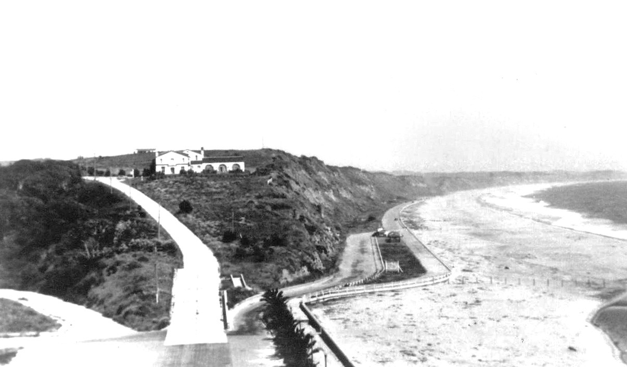
Rio del Mar and Beach Drive in 1930.

