Our Ocean Backyard
Column No. 327
Gary Griggs
Why Beaches?

Santa Cruz is and always has been a beach town, and we all probably have our own favorite beaches. But why do we have sandy beaches in some places and not in others? Most locals know where the beaches are, but how about where they aren’t, and why don’t we just have continuous sandy beaches from Natural Bridges to New Brighton?

The sand is out there, lots of it, but certain conditions are required for it to collect and form a beach. In an average year about 250,000 cubic yards of sand moves south and east along our shoreline driven by the dominant waves from the northwest. This amount of sand is a little difficult to envision, but it’s about 25,000 dump truck loads, or a continuous line of trucks extending for 118 miles along the shoreline. This would stretch from the Golden Gate to Monterey – every year. Another way to think about this volume is watching a truckload of sand passing along Cowells or Main Beach every 20 minutes, day in and day out, all year long. Some of that sand is visible on our beaches, but much of it is offshore.

So we have plenty of sand and lots of beaches. You know the big ones, Cowells, Main, Seabright, Twin Lakes, and then a continuous beach extending from New Brighton to Moss Landing. Then there are some smaller ones, Natural Bridges, Mitchell’s, Its Beach, and Capitola, for example. That’s about it except for some very small pocket beaches scattered along West Cliff and East Cliff.

One of the major factors needed to form a beach is some barrier, whether natural or artificial, to trap or retain the littoral drift. Cowells and Main Beaches were built up against San Lorenzo Point at the river mouth. The point forms a dam or barrier to the littoral transport for all that sand coming down from the north coast. Its Beach formed behind Lighthouse Point. Natural Bridges is held in place by another headland or point, which used to have three arches, but erosion has now reduced that to one.

Seabright and Capitola beaches are different stories. Seabright was historically quite narrow, widening at the east end because of the damming effect of Black Point. In the winter months, however, there was no Seabright Beach at high tide and waves often washed up to the top of the bluff (see attached photo of waves washing up against the old Scholl Mar castle, which was demolished in 1967). Sections of East Cliff Drive above Seabright Beach were undercut by the waves, and the isolated sections of the old concrete street are still visible today.

This all changed beginning in 1963 when the jetties of the Santa Cruz Small Craft Harbor were constructed. Within two years of completion, about 600,000 cubic yards of sand from upcoast had accumulated against the west jetty. Within a decade or so, Seabright had widened to about 200 feet next to San Lorenzo Point, and had extended nearly to the end of the jetty at the east end, creating a beach about 600 feet wide.

Capitola always had a small pocket beach in the summer months in the embayment at the mouth of Soquel Creek. This was one of the attractions that led to this village historically becoming Camp Capitola in the summer months. There was a negative impact of harbor construction on the beach at Capitola, however. All of that sand that was trapped by the west jetty to form Seabright Beach would have been carried by littoral drift to Capitola under natural conditions. Within two or three years, Capitola’s beach had essentially disappeared, which took its toll on the village’s summer economy.

To remedy the situation, in 1969 a 280-foot long stone groin was built at the east end of the beach and 27,000 cubic yards of quarry sand from the Santa Cruz Mountains were imported to rebuild the beach. This brought back the beach, and with the exception of the winter months, when much of the beach sand is often carried offshore due to the more energetic winter waves. Most of the sand returns the following spring and summer, however. So Capitola owes its beach today to that artificial barrier to littoral drift.

Another key factor in the formation of our beaches is the orientation of the shoreline compared to the direction of wave approach. Where the shoreline is oriented nearly east-west, waves are refracted or bent so as to approach the beach nearly parallel and sand can accumulate. Think of Cowells, Main, Seabright and Capitola beaches.

In contrast, where the coast trends closer to north-south, say from Lighthouse Point to Cowells, or from Pleasure Point all the way to New Brighton Beach, waves approach at a steeper angle. Sand is carried rapidly along these areas and very little sand remains to form beaches.

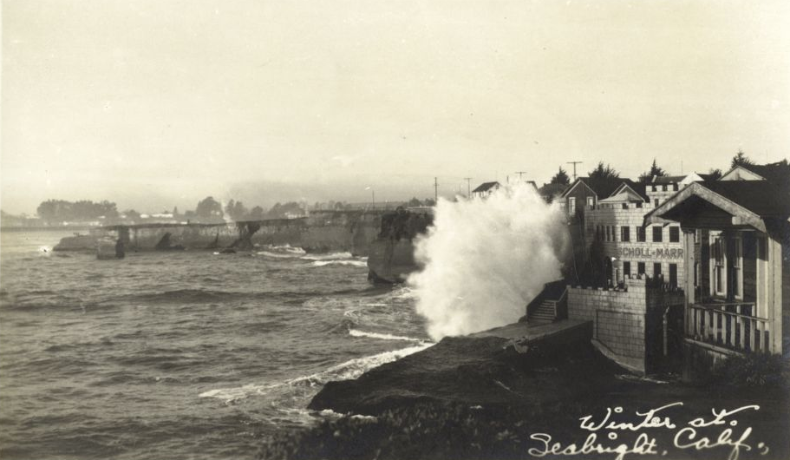
Seabright Beach in 1931. Courtesy of Special Collections, University library, University of California Santa Cruz. Santa Cruz County Historic Photograph Collection.

