Our Ocean Backyard
Gary Griggs
Article No. 336
Containers at Sea

Much of what we use in our daily lives, other than food, gets imported, and 90-95% of that comes by sea, passing offshore through our ocean backyard. Petroleum and petroleum products are a big component of our imports, about 9 million barrels every day, roughly 50% of our total demand. However, 56% of this comes from Canada and Mexico, with most of this through pipelines.

But if you look around for a minute, at your computer, your phone or other electronic devices, your wide-screen TV, your sports equipment, your car, and the clothes you’re wearing, the chances are really good that these were made somewhere other than in the USA. In addition, it’s also very likely that these arrived in a shipping container, well, except for your car, although it likely did come on a ship.

Shipping containers were first invented in the United States in the 1950s, and they marked a huge breakthrough in shipping. These containers were designed so that they could be easily and quickly transferred from a ship to a truck or train without the need for unpacking the cargo. Rather, the entire shipping container could be taken straight off the ship and put onto the next piece of transportation, which would take the cargo directly to its ultimation destination. By being a standard size and shape, they could be moved, stored, stacked and transferred efficiently and without problems.

There are now about 5,200 ships in the global container fleet and about 20 million containers around the planet, stacked in ports, on ships, or on trucks or trains. The U.S. imports about 20 million containers in a typical year, with the ports of Los Angeles and Long Beach ranking numbers 1 and 2 in total, together handling 28.5% of the total U.S container imports. Oakland ranks No.11 and adds an additional 3%. Oakland’s importance as a container port becomes evident if you drive up Highway 880. Approaching Oakland, you will notice much of the traffic in both directions consists of trucks carrying large shipping containers full of everything under the sun.

As transport by containers has increased, the size of the ships has also increased, following a similar pattern with oil tankers. The largest oil tankers in existence at the end of World War II were a little over 500 feet long, with size somewhat limited by the capacity of the Panama and Suez canals. As the global demand for oil increased, the size of crude oil carriers also increased as the industry realized that the larger the tanker, the more cheaply it could transport oil. The largest tankers are now over 1300 feet long, or over four football fields in length, and can carry up to 2 million barrels of oil or 84 million gallons. This is equivalent to 10% of the entire U.S. daily usage and enough to fill over five million average size automobile gas tanks. While the larger ships can carry oil at less overall cost, the potential size and impacts of a spill have also increased dramatically.

Larger ships led to increased operating efficiency and also improved environmental performance. The earliest container ships in the 1960s could carry 1530 TEU or twenty- foot equivalent units. Containers come in two different sizes, 20 and 40 feet long, but TEU is the standard unit for describing container ship capacity. The largest container ships now reach 1300 feet in total length and their capacity has increased to over 20,000 TEU, or over 10,000 40-foot-long steel shipping containers. Stacked end to end this would be a line of containers 75 miles long extending from Santa Cruz to San Francisco – on a single huge ship.

At any one time, there are approximately 5-6 million containers on the high seas. As the ships have gotten larger, the container loads have gotten higher. The distance between the engine room and the bridge on the largest vessels is twenty-one storys. Amazingly, these massive ships can be operated by a crew of just 13 people along with a very sophisticated computer system.

These very high stacks of heavy containers can, however, become unstable in large waves. And the well-traveled route across the North Pacific from Asian ports to the west coast is not exactly known for calm seas. The higher you stack the boxes on deck, the larger the forces they are subjected to and the more top heavy the ship becomes when encountering large waves, which happens more often than you might think. Next column I’ll describe what have become known as stack attacks.

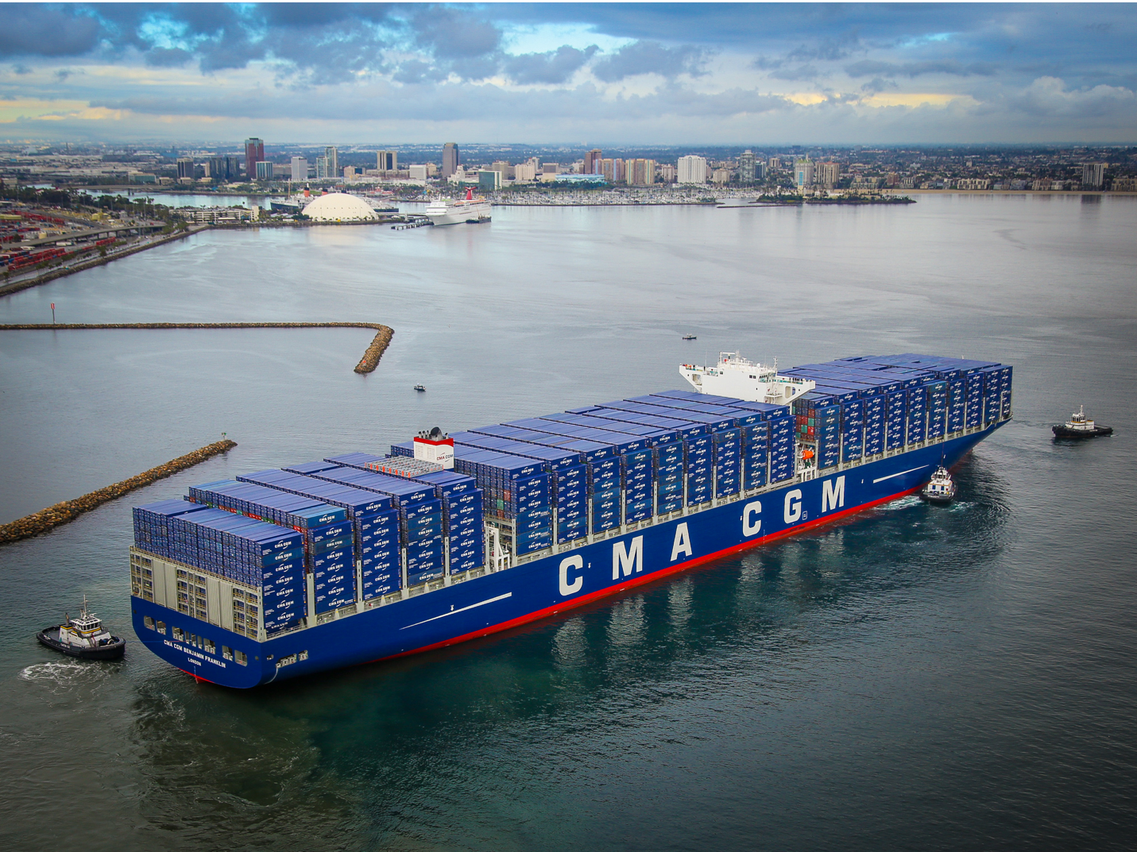
The Benjamin Franklin – One of largest container ships

