Our Ocean Backyard
Gary Griggs
Article 168
Unwanted Intrusions

People don’t do well drinking seawater, and most agricultural crops have little tolerance for elevated salt contents in irrigation water. Seaweed and eelgrass do just fine in seawater, but lettuce and tomatoes are a different story.

The earliest signs that something was amiss underground with our local freshwater came over 70 years ago in the coastal wells north and south of the Salinas River mouth when the water came up salty. All crops wilt and die pretty quickly when watered with salty water. The problem of seawater intrusion into coastal aquifers isn’t unique to the Monterey Bay region, but its continued inland migration since the 1940s has been well documented here.

In many coastal areas, fresh water aquifers outcrop on the shallow seafloor just offshore and are therefore in direct contact with seawater. As long as the water table in the aquifer on the adjacent dry land is high enough above sea level to keep fresh water is flowing seaward, the inflow of salt water is repelled and little or no contamination occurs.

The most important factors determining the elevation of the groundwater table are 1] the input or the amount of water that recharges or seeps into these aquifers from rainfall and stream flow or through artificial recharge; and 2] the outputs or the amount of water that leaves an aquifer from seepage into streams, discharge from springs, flow offshore, or pumped out through wells.

However, the increased demand for groundwater in many fertile coastal plain areas (the lower Pajaro and Salinas Valley areas, for example, but there are many, many others around the country) has led to the lowering of water tables below sea level and the intrusion of a wedge of seawater into coastal aquifers. Salt or brackish water soon appears in wells, making the water undrinkable and damaging to crops.

Since at least the early 1940s, continuous heavy pumping of groundwater for irrigation from the lower Salinas Valley between Moss Landing and Marina lowered the groundwater table and allowed seawater to intrude the upper 180-foot aquifer. The sediments in this and a deeper 400-foot aquifer consist primarily of the ancient river sands and gravels from the Salinas River channel, which are both very porous (can store water in the spaces between grains), and permeable (allows water to flow through them easily).

Wells were abandoned as they began to pump brackish water and new wells were drilled farther inland. In one small area around Castroville, over 100 wells were capped or abandoned between 1943 and 1968 because of high salt content. The saltwater plume continued to move inland, however, and by 2011 it had reached nearly to Salinas, over 8 miles from the shoreline.

There are several ways in which seawater intrusion can be controlled. Reducing pumping in coastal aquifers, moving wells inland, or importing water can allow the groundwater table to begin to recover, but this is difficult to get users to do voluntarily. Artificial recharge of intruded aquifers is another approach and through recharge wells the fresh water table can be elevated. This requires some new and significant source of water, however. Injection of wastewater treated to tertiary levels into aquifers where naturally occurring microbes can further clean the water is another approach, but this is a major effort and requires an advanced treatment plant.

There have been many studies over at least the past 35 years of whether or not seawater intrusion into the Purisima Formation in the Soquel-Aptos area has taken place. The Purisima is the source of about 2/3 of Soquel Creek Water District’s water supply so the issue of overpumping of the aquifer, which could lead to seawater intrusion, is an extremely important one.

While it is difficult to get good agreement on what is or isn’t happening beneath the surface, it does seem clear that the district has pumped more out of the aquifer for years than was recharged each year, which has lowered the water table. During the drought years of the late 1980s and early 1990s, the State Department of Water Resources reported that the water table was below sea level, although water tables have since partially recovered because of decreased water use, which has allowed pumping to be reduced. The water table is still below sea level in parts of the aquifer and seawater intrusion has been detected at a coastal monitoring well near Pleasure Point. The safest conclusion to draw during these drought times is that the Purisima aquifer is in danger of contamination from seawater intrusion.

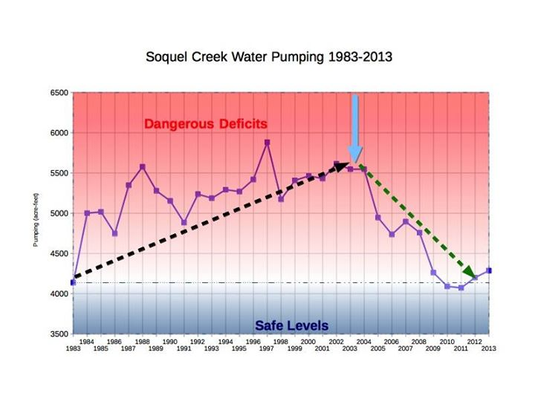

Groundwater pumping by the Soquel Creek Water District from 1983-2013 showing a transition from overdraft to safe levels of about 4000-4200 acre-feet/year (Soquel Creek Water District)

